**Notes on Operational Performance & Propulsion Workshop**

**19th November 2020**

1. **Mission Clarification General**

Take off fuel to 1500 ft no need to calculate distance since it is not counted in range.

Only use stepped cruise if it gives a significant fuel saving.

Section 4.14. There is no requirement for ETOPS.

Calculate the Reserves Fuel using the ground rules specified in Appendix 3 Section 3. For Approach & Landing use the Descent fuel calculated in 3.3 as indicated in 3.4.

1. **Mission Turboprop**

Take-off to Climb CAS (not necessarily 250 kts CAS) I suggest you use 1.7 minutes of Fuel Flow SLS ISA +15C conditions RC %0 .

Climb use best climb speed must be 250 knots or less.

Descent at best descent speed probably similar to Climb CAS.

Reserves

Diversion

Climb - same speed as for mission

Cruise speed best range speed at 20000 ft.

Descent same profile as mission

I have included a slide from AVDASI3 overleaf showing Specific Air Range v Mass & Mach Number for an A330 like Aircraft. From this you can see that a choice of M = 0.76 as Mcr is good compromise for a single defined Mach Cruise Number.

**Engine Scaling**

Turbofan: as per note Linear dimensions as Square Root of Scale Factor.

Turboprop: As per note Performance Thrust & Fuel Flow by SF. Assume inlet mass flow scales by SF and linear dimensions of nacelle & core scale by Square Root of SF. Use Pr0ppeller scaling rules as supplied.

Example: Thrust scale factor to meet performance requirements = 0.9

Power = 4847 x 0.9 = 4362

Engine & PGB + Propeller = 4362/3.2 = 1363 kg

Mount frame & Nacelle, etc.= 1363 x 0.40 = 545 kg

Pylon System Mass = (1363 + 606) x 0.2 = 394 kg

**Total mass on wing = 1363 + 545 +394 = 2302 kg**

Propeller Diameter in metres = √{(Max Power kW)/ (11 x No. Blades x π)}

**=** √{(4362)/ (11 x 6 x π)} = 4.59 m

**Powerplant Linear Dimensions for 4362 kW Engine.**  **Root of Scale Factor (m)**

Overall 4.596 x √0.9 4.36

Distance of c.g. from propeller spinner tip 2.297 x √0.9 2.179

**Engine Data for DOC Maintenance:**

Turbofan: By-pass ratio 8; Number of compressor stages 13

Turboprop: OPR 25; Number of compressor stages 11

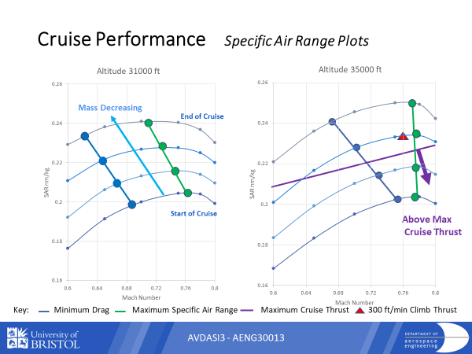

**Power Offtake for Turboprops**

Typically, in this turboprop configuration, the major power offtakes, whether as electrical only, or as a combination of electrical and hydraulic, are from units mounted on the final drive train through the propeller gear box (PGB). For this study, all-electrical offtake is assumed. In practice, for twin engined, large aeroplanes, the generation load for each engine will probably be split between two similar generators. This allows for the safest and most efficient generation, with the minimum/negligible disruption to the engine cycle by varying offtake loads. There is a separate, much smaller output electrical generator, dedicated to the engines own power requirements, and driven from the core engine, most commonly the highest pressure shaft. Sometimes, but not necessarily, this unit takes the form of a starter-generator. The large service output to the aeroplane would be broadly the same for either a turboprop variant or a turbofan i.e. a nominal 180 kW per engine, and the small load of the engine dedicated generator is not really significant to the overall cycle. The fuel cost of the power generation is already built into the overall performance models as a loss, at a constant nominal rate. This sort of configuration also makes a simple basis for use of hybrid propulsive power supplies, with the big PGB-mounted generators becoming even larger, and sharing the propulsive load as required, with the gas turbine.

DR F A Hewitt 12 11 2019